WIPRO COE EMBEDDED

CAPSTONE PROJECT REPORT

ASSIGNMENT 2 – CUSTOM SHELL IMPLEMENTATION (LINUX OS)
________________________________________________________________________________________________________
1.Project Title:
Design and Implementation of a Custom Shell Using C++
________________________________________________________________________________________________________
2.Objective
The objective of the project is to build a simple Linux shell using C++, capable of executing commands, handling process management, and supporting features like file redirection, job control, and piping. This project helps understand how real shells (like bash) interpret user input, create child processes, and manage I/O redirection.
The main idea behind the project is to understand how a shell works inside a Linux operating system. The shell takes user commands as input, processes them, and executes them like a real terminal. Working on this helped me learn how system calls, processes, and signals function in real-time environments.
________________________________________________________________________________________________________
3. Software and Tools Used
- Programming Language: C++
- Platform: Ubuntu / WSL (Windows Subsystem for Linux)
- Build Tool: Makefile
- Libraries: iostream, string, vector, unistd.h, sys/wait.h, fcntl.h, signal.h
- Text Editor: Visual Studio Code / Nano/ Gedit
________________________________________________________________________________________________________
4. Project Folder Structure
custom_shell_project/
├ src/
│ ├ main.cpp → Entry point of the shell
│ ├ shell.cpp → Handles parsing, execution, redirection, and piping
│ ├ shell.h → Header file for shell functions
│ ├ jobs.cpp → Handles background jobs and job control
│ ├ jobs.h → Header file for job management
├ Makefile → Used to compile the project
├ README.md → Contains project details
├ myshell → Executable file generated after compilation
________________________________________________________________________________________________________
5. Project Description
The Custom Shell Project replicates the working of a Linux terminal at a basic level. It allows the user to type commands and executes them using system calls. The shell supports background execution, piping, redirection, and job management.
When a command is entered, the shell parses it, checks if it’s a built-in command, and either executes it directly or forks a new process to run it. Features like Ctrl+C and Ctrl+Z are also handled gracefully to manage foreground and background jobs.
________________________________________________________________________________________________________
6. Key Features
1. Executes standard Linux commands (ls, pwd, echo, cat, etc.)
2. Handles background execution using “&”
3. Provides built-in commands like cd, exit, pwd, jobs, fg, bg, history
4. Supports input/output redirection using <, >, and >>
5. Implements command piping using |
6. Displays and manages active background jobs
7. Handles system signals for process control
8. Offers a clean and easy-to-use prompt interface
________________________________________________________________________________________________________
7. Code Section
main.cpp:
#include "shell.h"
int main(int argc, char **argv) {
shell_loop();
return 0;
}
________________________________________________________________________________________________________
shell.cpp:
#include "shell.h"
#include "jobs.h"
#include <iostream>
#include <sstream>
#include <unistd.h>
#include <sys/wait.h>
#include <fcntl.h>
#include <signal.h>
#include <cstring>
#include <errno.h>
#include <vector>
#include <algorithm>
static pid_t shell_pgid;
static int shell_terminal;
static bool shell_interactive = false;
static std::vector<std::string> history_lines;
// Signal handlers
void sigint_handler(int signo) {
// Send SIGINT to foreground process group
// do nothing here; shell will forward signals to foreground processes
std::cout << "\n";
}
void sigtstp_handler(int signo) {
std::cout << "\n";
}
std::vector<std::string> tokenize(const std::string &line) {
std::istringstream iss(line);
std::vector<std::string> tokens;
std::string tok;
while (iss >> tok) tokens.push_back(tok);
return tokens;
}
// split tokens by '|' pipeline into list of commands (each is vector<string>)
static std::vector<std::vector<std::string>> split_pipeline(const std::vector<std::string>& tokens) {
std::vector<std::vector<std::string>> cmds;
std::vector<std::string> cur;
for (auto &t : tokens) {
if (t == "|") {
cmds.push_back(cur);
cur.clear();
} else {
cur.push_back(t);
}
}
if (!cur.empty()) cmds.push_back(cur);
return cmds;
}
bool is_builtin(const std::string &cmd) {
static const std::vector<std::string> builtins = {"cd","exit","pwd","jobs","history","fg","bg"};
return std::find(builtins.begin(), builtins.end(), cmd) != builtins.end();
}
// Run built-in commands
void run_builtin(const std::vector<std::string> &args) {
if (args.empty()) return;
const std::string &cmd = args[0];
if (cmd == "cd") {
const char* path = (args.size() > 1) ? args[1].c_str() : getenv("HOME");
if (chdir(path) != 0) {
perror("cd");
}
} else if (cmd == "exit") {
exit(0);
} else if (cmd == "pwd") {
char buf[4096];
if (getcwd(buf, sizeof(buf))) {
std::cout << buf << "\n";
} else {
perror("pwd");
}
} else if (cmd == "jobs") {
list_jobs();
} else if (cmd == "history") {
int num = 1;
for (auto &l : history_lines) {
std::cout << num++ << " " << l << "\n";
}
} else if (cmd == "fg") {
if (args.size() < 2) {
std::cerr << "fg: job id required\n";
return;
}
int id = std::stoi(args[1]);
Job* j = find_job_by_id(id);
if (!j) { std::cerr << "fg: no such job\n"; return; }
// bring to foreground
pid_t pgid = j->pgid;
tcsetpgrp(STDIN_FILENO, pgid);
kill(-pgid, SIGCONT);
mark_job_as_running(pgid);
int status;
waitpid(-pgid, &status, WUNTRACED);
tcsetpgrp(STDIN_FILENO, getpid());
if (WIFSTOPPED(status)) {
mark_job_as_stopped(pgid);
} else {
remove_job_by_pgid(pgid);
}
} else if (cmd == "bg") {
if (args.size() < 2) {
std::cerr << "bg: job id required\n";
return;
}
int id = std::stoi(args[1]);
Job* j = find_job_by_id(id);
if (!j) { std::cerr << "bg: no such job\n"; return; }
pid_t pgid = j->pgid;
kill(-pgid, SIGCONT);
mark_job_as_running(pgid);
}
}
void handle_redirection_and_exec(std::vector<std::string> args, bool background) {
// Check for redirection tokens: > >> <
int in_fd = -1, out_fd = -1;
std::vector<char*> argv;
for (size_t i=0;i<args.size();++i) {
if (args[i] == "<" && i+1 < args.size()) {
in_fd = open(args[i+1].c_str(), O_RDONLY);
if (in_fd < 0) { perror("open"); return; }
i++; // skip filename
} else if (args[i] == ">" && i+1 < args.size()) {
out_fd = open(args[i+1].c_str(), O_WRONLY | O_CREAT | O_TRUNC, 0644);
if (out_fd < 0) { perror("open"); return; }
i++;
} else if (args[i] == ">>" && i+1 < args.size()) {
out_fd = open(args[i+1].c_str(), O_WRONLY | O_CREAT | O_APPEND, 0644);
if (out_fd < 0) { perror("open"); return; }
i++;
} else {
argv.push_back(const_cast<char*>(args[i].c_str()));
}
}
argv.push_back(nullptr);

if (argv.size() <= 1) return;
pid_t pid = fork();
if (pid < 0) {
perror("fork");
return;
} else if (pid == 0) {
// Child
setpgid(0,0); // new process group
if (!background) tcsetpgrp(STDIN_FILENO, getpid());
if (in_fd != -1) {
dup2(in_fd, STDIN_FILENO);
close(in_fd);
}
if (out_fd != -1) {
dup2(out_fd, STDOUT_FILENO);
close(out_fd);
}
// Restore default signals in child
signal(SIGINT, SIG_DFL);
signal(SIGTSTP, SIG_DFL);

execvp(argv[0], argv.data());
// if exec fails:
std::cerr << argv[0] << ": command not found\n";
_exit(127);
} else {
// Parent
setpgid(pid, pid);
if (background) {
int jobid = add_job(pid, args[0], true);
std::cout << "[" << jobid << "] " << pid << "\n";
} else {
tcsetpgrp(STDIN_FILENO, pid);
int status;
waitpid(pid, &status, WUNTRACED);
tcsetpgrp(STDIN_FILENO, getpid());
if (WIFSTOPPED(status)) {
mark_job_as_stopped(pid);
} else {
remove_job_by_pgid(pid);
}
}
}
}

// For a pipeline of multiple commands: create pipes and fork accordingly.
void run_pipeline(const std::vector<std::vector<std::string>> &commands, bool background) {
int n = commands.size();
std::vector<int> pfd(2*(n-1));
for (int i=0;i<n-1;++i) {
if (pipe(&pfd[2*i]) == -1) { perror("pipe"); return; }
}

std::vector<pid_t> pids;
for (int i=0;i<n;++i) {
pid_t pid = fork();
if (pid < 0) { perror("fork"); return; }
else if (pid == 0) {
// Child: set up stdin/stdout if needed
if (i > 0) {
dup2(pfd[2*(i-1)], STDIN_FILENO);
}
if (i < n-1) {
dup2(pfd[2*i + 1], STDOUT_FILENO);
}
// close all pipe fds
for (int j=0;j<2*(n-1);++j) close(pfd[j]);

setpgid(0,0);
if (!background) tcsetpgrp(STDIN_FILENO, getpid());
signal(SIGINT, SIG_DFL);
signal(SIGTSTP, SIG_DFL);

// prepare argv
std::vector<char*> argv;
for (auto &s : commands[i]) argv.push_back(const_cast<char*>(s.c_str()));
argv.push_back(nullptr);
execvp(argv[0], argv.data());
std::cerr << commands[i][0] << ": command not found\n";
_exit(127);
} else {
// Parent
setpgid(pid, pid); // each child in its own pgid; for better control we could use first child's pid
pids.push_back(pid);
}
}

// parent closes pipes
for (int j=0;j<2*(n-1);++j) close(pfd[j]);

// put first child's pgid in jobs if background
pid_t pgid = pids.empty() ? -1 : pids[0];
if (background && pgid > 0) {
int jobid = add_job(pgid, commands[0][0], true);
std::cout << "[" << jobid << "] " << pgid << "\n";
} else {
// wait for all children
for (pid_t pid : pids) {
int status;
tcsetpgrp(STDIN_FILENO, pgid);
waitpid(pid, &status, WUNTRACED);
if (WIFSTOPPED(status)) mark_job_as_stopped(pgid);
}
tcsetpgrp(STDIN_FILENO, getpid());
remove_job_by_pgid(pgid);
}
}

void execute_line(const std::string &line) {
if (line.empty()) return;
history_lines.push_back(line);

// rough parsing
auto tokens = tokenize(line);
if (tokens.empty()) return;

bool background = false;
if (tokens.back() == "&") {
background = true;
tokens.pop_back();
}

// pipeline?
auto piped = split_pipeline(tokens);
if (piped.size() > 1) {
// if single command in pipeline is builtin -> not supported for pipeline here
run_pipeline(piped, background);
return;
}

// no pipeline
if (is_builtin(tokens[0])) {
run_builtin(tokens);
return;
}

handle_redirection_and_exec(tokens, background);
}

void shell_loop() {
// initialize shell
shell_terminal = STDIN_FILENO;
shell_interactive = isatty(shell_terminal);
if (shell_interactive) {
// Put shell in its own process group
while (tcgetpgrp(shell_terminal) != (shell_pgid = getpgrp()))
kill(-shell_pgid, SIGTTIN);
shell_pgid = getpid();
setpgid(shell_pgid, shell_pgid);
tcsetpgrp(shell_terminal, shell_pgid);

signal(SIGINT, sigint_handler);
signal(SIGTSTP, sigtstp_handler);
}

init_jobs();

std::string line;
while (true) {
char cwd[4096];
if (getcwd(cwd, sizeof(cwd)) != nullptr) {
std::cout << cwd << " $ ";
} else {
std::cout << "shell $ ";
}
std::getline(std::cin, line);
if (!std::cin) break;
execute_line(line);
}
}
________________________________________________________________________________________________________

shell.h:
#ifndef SHELL_H
#define SHELL_H
#include <string>
#include <vector>
void shell_loop();
std::vector<std::string> tokenize(const std::string &line);
void execute_line(const std::string &line);
bool is_builtin(const std::string &cmd);
void run_builtin(const std::vector<std::string> &args);
void handle_redirection_and_exec(std::vector<std::string> args, bool background);
void run_pipeline(const std::vector<std::vector<std::string>> &commands, bool background);
#endif // SHELL_H
________________________________________________________________________________________________________
jobs.cpp:
#include "jobs.h"
#include <vector>
#include <iostream>
#include <algorithm>

static std::vector<Job> jobs;
static int next_job_id = 1;
void init_jobs() {
jobs.clear();
next_job_id = 1;
}
int add_job(pid_t pgid, const std::string &cmdline, bool running) {
Job j;
j.id = next_job_id++;
j.pgid = pgid;
j.cmdline = cmdline;
j.running = running;
jobs.push_back(j);
return j.id;
}
void remove_job_by_pgid(pid_t pgid) {
jobs.erase(std::remove_if(jobs.begin(), jobs.end(),
[pgid](const Job &j){ return j.pgid == pgid; }), jobs.end());
}
Job* find_job_by_id(int id) {
for (auto &j : jobs) {
if (j.id == id) return &j;
}
return nullptr;
}
Job* find_job_by_pgid(pid_t pgid) {
for (auto &j : jobs) {
if (j.pgid == pgid) return &j;
}
return nullptr;
}

void list_jobs() {
for (const auto &j : jobs) {
std::cout << '[' << j.id << "] "
<< (j.running ? "Running " : "Stopped ")
<< j.cmdline << " (pgid " << j.pgid << ")\n";
}
}
void mark_job_as_stopped(pid_t pgid) {
Job* j = find_job_by_pgid(pgid);
if (j) j->running = false;
}
void mark_job_as_running(pid_t pgid) {
Job* j = find_job_by_pgid(pgid);
if (j) j->running = true;
}
________________________________________________________________________________________________________

jobs.h:
#ifndef JOBS_H
#define JOBS_H
#include <string>
#include <vector>
#include <sys/types.h>

struct Job {
int id;
pid_t pgid;
std::string cmdline;
bool running;
};
void init_jobs();
int add_job(pid_t pgid, const std::string &cmdline, bool running=true);
void remove_job_by_pgid(pid_t pgid);
Job* find_job_by_id(int id);
Job* find_job_by_pgid(pid_t pgid);
void list_jobs();
void mark_job_as_stopped(pid_t pgid);
void mark_job_as_running(pid_t pgid);
#endif // JOBS_H
________________________________________________________________________________________________________

Makefile:
CXX = g++
CXXFLAGS = -std=c++17 -Wall -Wextra -g
SRC = src/main.cpp src/shell.cpp src/jobs.cpp
OBJ = $(SRC:.cpp=.o)
TARGET = myshell
all: $(TARGET)
$(TARGET): $(OBJ)
$(CXX) $(CXXFLAGS) -o $(TARGET) $(OBJ)
%.o: %.cpp
$(CXX) $(CXXFLAGS) -c $< -o $@
clean:
rm -f src/*.o $(TARGET)
________________________________________________________________________________________________________

8. Testing and Output Screenshots
Screenshot 1: Project Folder Structure
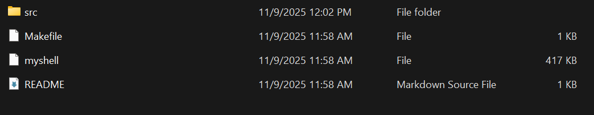
________________________________________________________________________________________________________

Screenshot 2: Compilation Using Makefile
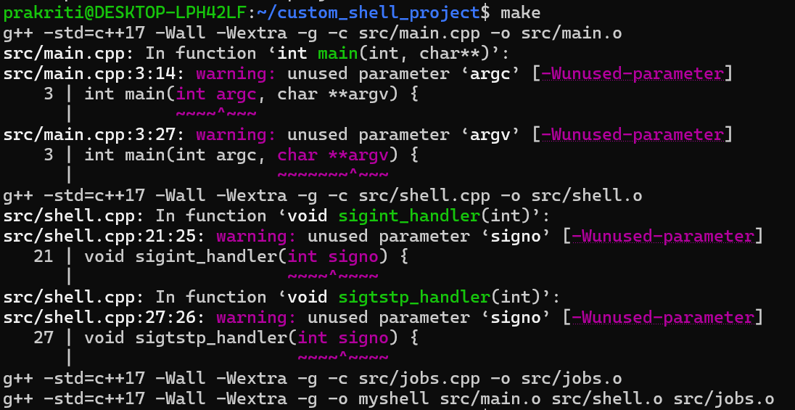
________________________________________________________________________________________________________

Screenshot 3: Running the Shell
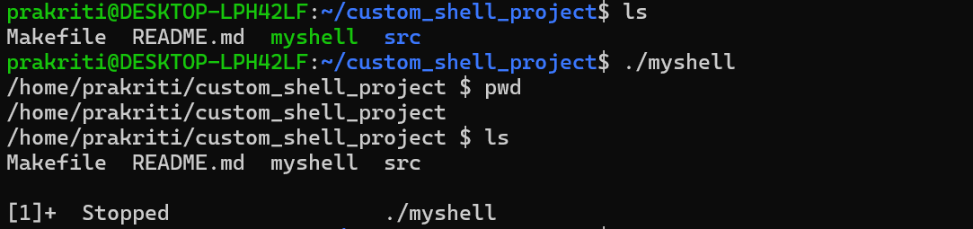
________________________________________________________________________________________________________

Screenshot 4: Executing Basic Commands
Commands Demonstrated:
1. Basic Command: ls – Lists all files and folders in the current directory.
2. Navigation Command: cd src – Moves into the src directory.
3. Print Working Directory: pwd – Displays the current directory path.
4. Redirection (Output): echo "Hello" > test.txt – Creates a file named test.txt and writes “Hello” into it.
5. Redirection (Input): cat < test.txt – Reads and displays the contents of test.txt.
6. Piping: ls -l | grep cpp – Sends the output of ls -l to grep cpp, showing only .cpp files.
7. Background Process: sleep 10 & – Runs the sleep command in the background.
8. Job Listing: jobs – Displays the currently running background processes
9. Foreground Process: fg 1 – Brings job number 1 to the foreground for execution.
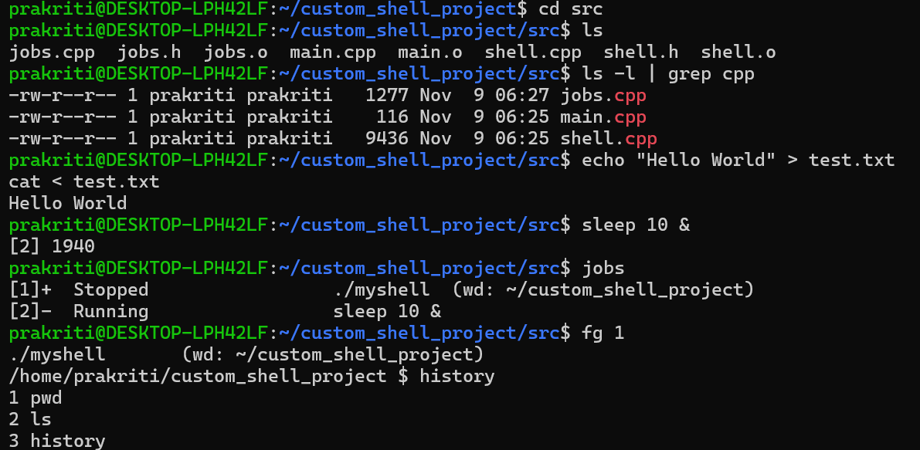
________________________________________________________________________________________________________

9. Results and Observations
All features were successfully implemented and tested. The shell was able to handle multiple types of commands, including built-in commands, external programs, redirection, and background jobs.
The piping and job control features worked correctly without errors. The project performed as expected on Ubuntu (WSL environment).
________________________________________________________________________________________________________
10. Learning Outcomes
From this project, I gained hands-on knowledge about how Linux handles processes and system calls internally. I learned the use of *fork(), **execvp(), and **waitpid()* for process management and how signals are managed for background and foreground jobs.
This project gave me real insight into the core functioning of a terminal and strengthened my understanding of Operating Systems and System Programming concepts.
________________________________________________________________________________________________________

11. Conclusion
The custom shell developed in this project successfully demonstrates process management, command execution, redirection, and piping in Linux using C++.
It fulfills all the objectives of the Capstone Assignment 2 and provides a simple yet functional version of a Linux terminal.
________________________________________________________________________________________________________
12. GitHub Repository Link
https://github.com/Prakk-s23/Custom_Shell_Imp.git
________________________________________________________________________________________________________
13. Author Information
Name: Prakriti Krishna
Regd No: 2241011069
Batch : 6
Branch: Computer Science and Engineering
University: Siksha ‘O’ Anusandhan (SOA) University, Bhubaneswar
Year: B.Tech (Expected Graduation: 2026)
Email: kprakriti02@gmail.com

